Job Description – Assembly TechniciaCompany Summary
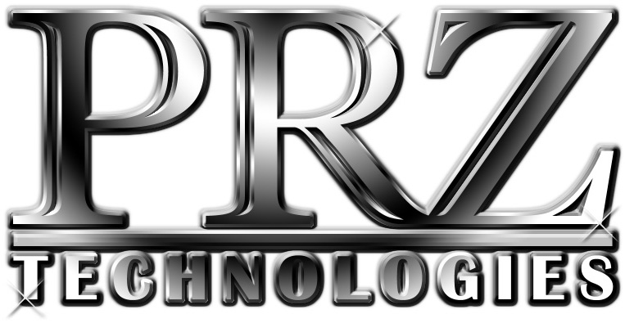
P.O. BOX 369 / LANCASTER, NY 14086
PHONE: 716-683-1300 x 200
WEBSITE: www.prztech.com
EMAIL: Jessica.messmer@prztech.com

Locally owned and operated since 1994, PRZ Technologies, Inc. designs and builds work holding, fixturing, tooling and special machines for the CNC machine tool industry.

Using our knowledge, experience and creative thinking, our talented team of design engineers and toolmakers produce advanced CNC Manufacturing solutions that surpass customer expectations in productivity, reliability, repeatability, quality and performance.

We rely on ingenuity and creativity to produce the finest components available. All PRZ Technologies employees possess self-motivation and a team spirit.

We make your advanced CNC Manufacturing ideas a reality.

Benefits Offered
Full-time PRZ employees receive full health insurance benefits, 11 days of paid time off after a full year of employment, six major holidays, and after one year of employment, a 401K with up to 4% company match. PRZ also offers AFLAC supplemental disability and other insurances.

Organizational Information
Job Title: Assembly Technician
Salary: $20.00 - $32.00 per hour; Commensurate with ability and experience
Job Type: Full-time 40hrs plus overtime as required

Job Summary
This position involves the ability to assemble, test, and troubleshoot complex mechanical prototype assemblies. The Assembly Technician requires an individual with a fundamental machine tool background who has experience in electrical/mechanical repair, assembly, hydraulics, pneumatics, machining, and print reading. Requires some manual machining abilities, print reading, organizational skills, and some office/computer skills. The environment is fast paced, due to short lead times and multiple product/projects with parallel time lines. Assembly Technician would report to the Assembly Lead. There is heavy interaction between Assembly Technician and various teams, requiring good communication skills and a strong knowledge of machine tool and related fields. Small company atmosphere requires changing responsibilities and assignments at times.

Duties and Responsibilities
- Strong mechanical background in general, understanding of basic mechanisms and principles, hands on ability.
- Precision assembly, such as automotive engine building, etc. preferred.
- Familiarity with CNC Machine Tools, general operations.
- Basic knowledge of hydraulics and operating principles as applied to the work-holding applications.
- Ability to view and understand 3D models and 2D Drawings.
- Basic Knowledge of Excel and Word, or equivalent.
- Ability to effectively troubleshoot prototype type builds and problem solve.
- Good vision of what a product will look like by interpreting prints.
- The ability to see the large picture and at the same time understand the details required to complete the product for delivery.
- Create and maintain Fixture inspection reports, documentation and various shipping docs.
- Follow established assembly procedures on a consistent basis
- Must be able to communicate with team members effectively.
- Ability to work in a team environment and comfortable with sharing and listening to others’ opinions and ideas.
- Ability to work with minimal supervision, realize the task at hand, understand and meet target completion dates.
- Ability to Travel when required and work off-site at Customer facility in a clean and professional manner representative of PRZ Technologies and its core values.
- TIG welding skills a plus

Experience/Skills Required:
- Education: HS Diploma or equivalent.
- Trade/technical/vocational training related to machining and/or other related skilled trades a plus

This job description is not intended to be all-encompassing; employees will/may perform other related duties to meet the ongoing needs of the organization. PRZ Technologies is an Equal Opportunity Employer and welcomes applications from all suitably qualified persons regardless of their race, sex, disability, religion/belief, sexual orientation, or age. Employment is at-will and neither this job description nor any other oral or written representations may be considered a contract for any specific period of time. For full descriptions of duties please visit: www.prztech.com/employment

